**Docker Networking:**

Types of Network:

1.Default bridge

2.Custom bridge

3.Host

4.Overlay

5.MACvLan

6.None

7.Iplan

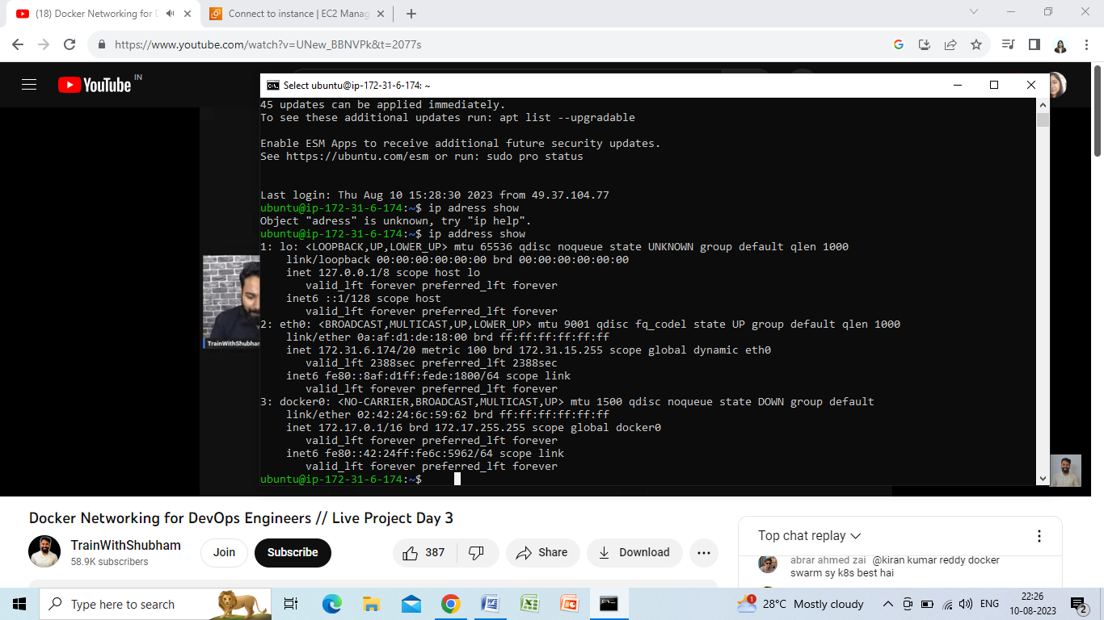

To check the ip address in host:

Ip address show

a.loopback ip address:

the internal ip address of the host device:

b.eth0:

the ip address to connect with external device

c.docker 0:

ip address reserved for docker container

to give user level access to docker,

sudo usermod –aG docker $USER

SINCE,docker is actually works as root user

By default docker has 3 networks listed:

They are:

1.host

2.bridge

3.none

Command:

docker network ls

to create an nginx container:

-docker run –d –name nginx nginx

-docker exec –it imageid

(this will go inside the docker container)

To inspect default network:

Docker inspect bridge

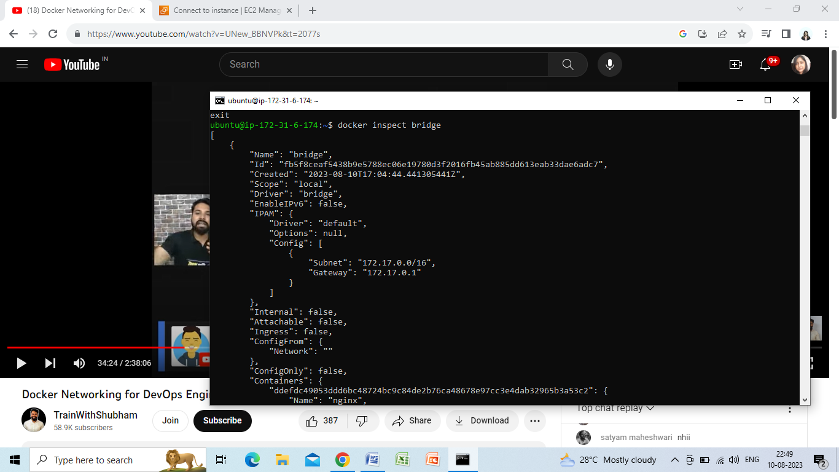

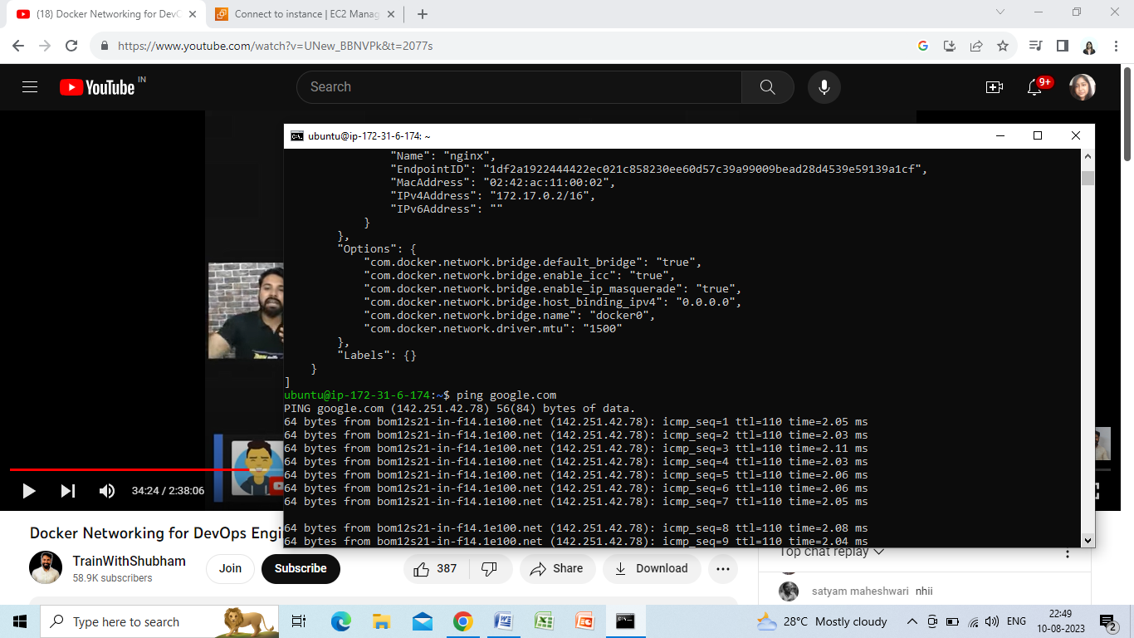

Since the default network is bridge we are able to connect with the outside net.

In bridge network: we have to map server:docker port

In host network: we don’t have to map any port it is mapped by default

To create custom bridge network:

-docker network create nameofnetwork